**ALL INDIA SENIOR SECONDARY EXAMS**

**2018-19**

**Topic :** **Quiz Program**

A close up of a sign

Description generated with very high confidence

**Submitted to:**

**Mr. C.M. Agarwal**

**(P.G.T. Computer Sciences)**

**Submitted by:**

**Jai Parwani Zuhar ASRAW**

Roll no **~~-~~** Roll no **~~-~~**

***Acknowledgement***

I am grateful to*my teacher Mr.* C.M. Agarwal. He gave us moral support and guided me in different matters regarding the topic. He has been very kind and patient, whilst suggesting to me the outlines of this project, and correcting my doubts. I thank him for his overall support.*My project has been a success only because of* *his guidance.*

***Name of Student:***

* ***Jai Parwani***

***Roll no. -***

* ***Zuhar***

***Roll no. -***

Certificate

This is to certify that zuhar Ashraw & Jai parwani of Class XII (Science) of S.J. Public School, Jaipur, have completed their project file under my supervision. They have taken proper guidelines and shown utmost sincerity in completion of this project.

I certify that this project is up to my expectation and as per the guidelines issued by CBSE.

Mr. C.M. Agarwal

(I.P. Teacher)

(Signature)

**Quiz Project**

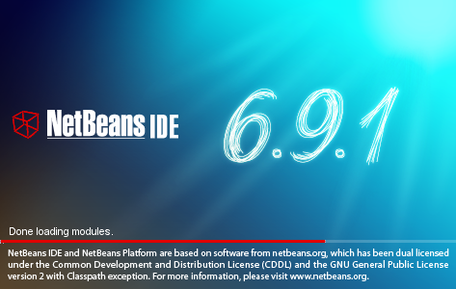

**This is the first window which will appear as soon as we double click on the icon of NetBeans IDE 6.9.1 which is the java platform of our program.**

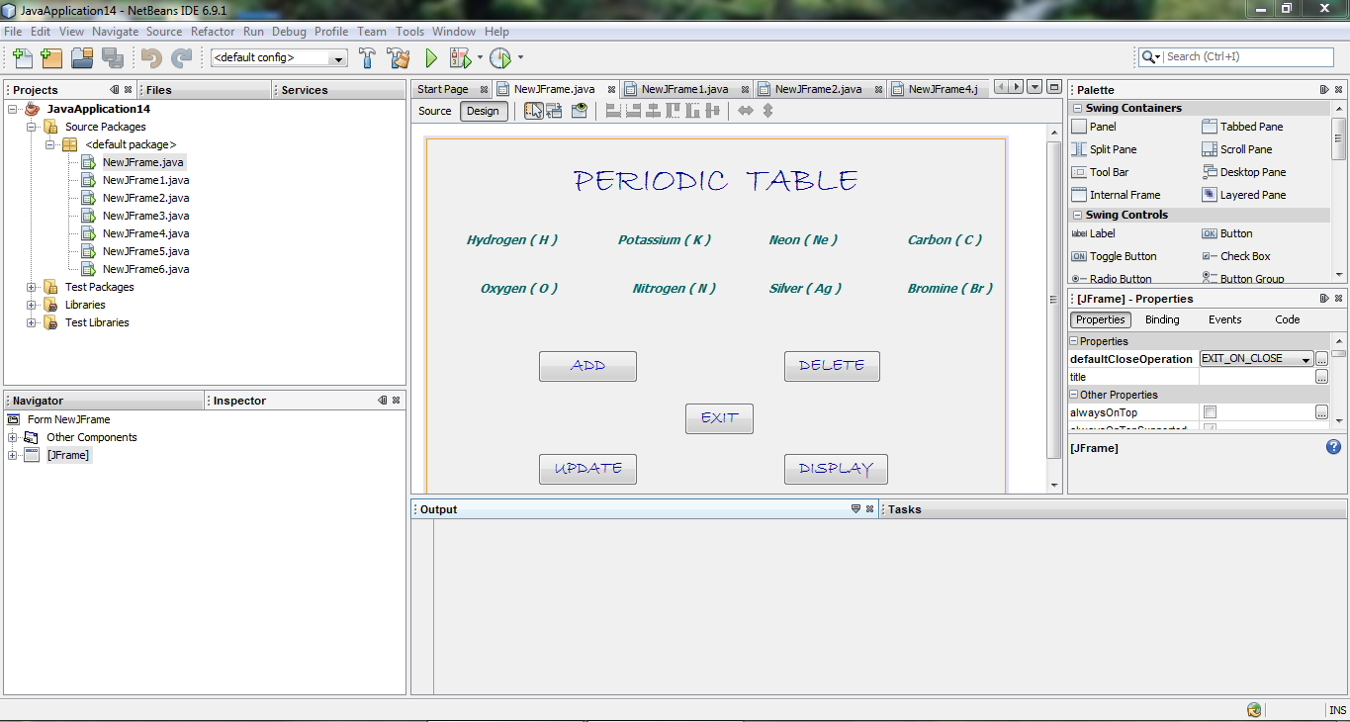

*First of all we opened the Java Platform i.e. NetBeans IDE 6.9.1 then start up a new project which we have given name “****Quiz Program****” .Then step- by - step we made up the java programs like LOGIN Form , Test Form , result Form , etc.*

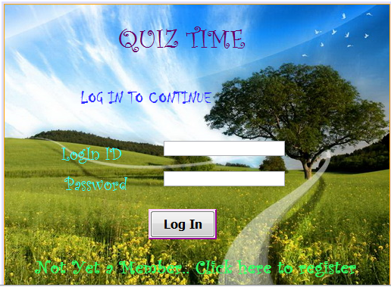

**Fig. LOGIN FORM**

**Coding For LOGIN Button :**

*private void loginBTNActionPerformed(java.awt.event.ActionEvent evt) {*

*String PWord = new String(Password.getPassword());*

*String Id = ID.getText();*

*try {*

*Class.forName("java.sql.Driver");*

*Connection conn = DriverManager.getConnection("jdbc:mysql://localhost/quizdb", "root", "mysql");*

*Statement stmt = conn.createStatement();*

*stmt = conn.createStatement();*

*String sql = "select * from LogIn where ID = '" + Id + "'";*

*ResultSet rs = stmt.executeQuery(sql);*

*rs.next();*

*String str = rs.getString("Password");*

*if(str.equals(PWord))*

*{*

*Menu m = new Menu(Id);*

*m.setVisible(true);*

*this.setVisible(false);*

*}*

*else*

*{*

*InvalidLBL.setText("Incorrect ID or Password");*

*}*

*} catch (Exception e) { InvalidLBL.setText("Incorrect ID or Password");}*

*}*

**Coding for resistration form appearance :**

*private void regLBLMouseClicked(java.awt.event.MouseEvent evt) {*

*Register r = new Register();*

*r.setVisible(true);*

*this.setVisible(false);*

*}*

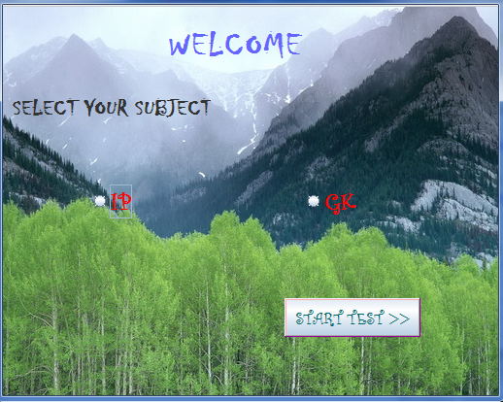

**Fig. MENU FORM**

public Menu(String id) {

initComponents();

ID = id;

}

**Coading For Start Test Button :**

private void startTestBTNActionPerformed(java.awt.event.ActionEvent evt) {

// TODO add your handling code here:

String subject = null;

if(IP.isSelected()) {

subject = "ip";

}

else if(GK.isSelected()) {

subject = "gk";

}

if (subject != null)

{

Test t = new Test(subject,ID);

t.setVisible(true);

this.setVisible(false);

}

}

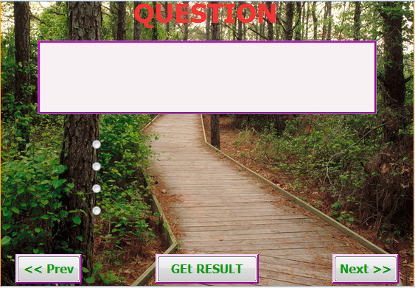

**Fig. TEST FORM**

import java.sql.*;

import javax.swing.JOptionPane;

public class Test extends javax.swing.JFrame {

String ID;

String Subject;

int index =1;

int max =0;

int result = 0;

char [] answers;

/** Creates new form Test */

public Test()

{

initComponents();

}

public Test(String subject, String id)

{

initComponents();

ID = id;

Subject = subject;

PrevBTN.setVisible(false);

try

{

Class.forName("java.sql.Driver");

Connection conn = DriverManager.getConnection("jdbc:mysql://localhost/quizdb", "root", "mysql");

Statement stmt = conn.createStatement();

String sql = "select max(SNo) from " + Subject;

ResultSet rs = stmt.executeQuery(sql);

rs.next();

max = rs.getInt(1);

answers = new char[max];

for(int i=0; i<max;i++) {

answers[i] = 'e';

}

rs.close();

stmt.close();

conn.close();

getQues();

}

catch(Exception r){ JOptionPane.showMessageDialog(null,""+ r);

}

}

private void getQues()

{

try

{

Class.forName("java.sql.Driver");

Connection conn = DriverManager.getConnection("jdbc:mysql://localhost/quizdb", "root", "mysql");

Statement stmt = conn.createStatement();

String sql = "select * from " + Subject + " where SNo = " + index;

ResultSet rs = stmt.executeQuery(sql);

rs.next();

QuesTA.setText("\nQ" + index + ". " + rs.getString(2));

a.setText(rs.getString("a"));

b.setText(rs.getString("b"));

c.setText(rs.getString("c"));

d.setText(rs.getString("d"));

a.setSelected(answers[index-1] == 'a');

b.setSelected(answers[index-1] == 'b');

c.setSelected(answers[index-1] == 'c');

d.setSelected(answers[index-1] == 'd');

e.setSelected(answers[index-1] == 'e');

rs.close();

stmt.close();

conn.close();

}

catch(Exception r){ JOptionPane.showMessageDialog(null,""+ r); }

}

**Coding For Prev Button**

private void PrevBTNActionPerformed(java.awt.event.ActionEvent evt) {

index--;

getQues();

if(index == 1) {

PrevBTN.setVisible(false);

}

if(index < max) {

NextBTN.setVisible(true);

}

}

**Coding For NEXT Button :**

private void NextBTNActionPerformed(java.awt.event.ActionEvent evt) {

index++;

getQues();

if(index == max) {

NextBTN.setVisible(false);

}

if(index > 1) {

PrevBTN.setVisible(true);

}

}

**Coding For RESULT Button**

private void ResultBTNActionPerformed(java.awt.event.ActionEvent evt) {

try

{

Class.forName("java.sql.Driver");

Connection conn = DriverManager.getConnection("jdbc:mysql://localhost/quizdb", "root", "mysql");

Statement stmt = conn.createStatement();

String sql = "select Result from " + Subject;

ResultSet rs = stmt.executeQuery(sql);

int i = 0;

while(rs.next())

{

char ans = rs.getString(1).charAt(0);

if(ans == answers[i]) {

result++;

}

i++;

}

float res = ((float)result * 100 ) / max;

sql = "Select " + Subject + "result from Result where ID = '" + ID + "'";

rs = stmt.executeQuery(sql);

rs.next();

if(res > rs.getFloat(1))

{

sql = "update Result set " + Subject + "result = " + res + " where ID = '" + ID + "'";

stmt.executeUpdate(sql);

}

stmt.close();

conn.close();

this.setVisible(false);

new Result(res,ID).setVisible(true);

}

catch(Exception r){ JOptionPane.showMessageDialog(null,r); }

}

private void aActionPerformed(java.awt.event.ActionEvent evt) {

answers[index-1] = 'a';

}

private void bActionPerformed(java.awt.event.ActionEvent evt) {

answers[index-1] = 'b';

}

private void cActionPerformed(java.awt.event.ActionEvent evt) {

answers[index-1] = 'c';

}

private void dActionPerformed(java.awt.event.ActionEvent evt) {

answers[index-1] = 'd';

}

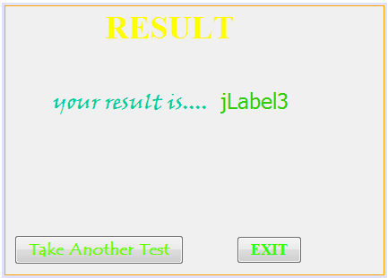

**Fig. RESULT FORM**

public class Result extends javax.swing.JFrame {

float result;

String ID;

/** Creates new form Result */

public Result() {

initComponents();

}

public Result(float res, String id)

{

initComponents();

result = res;

ID = id;

jLabel3.setText(res + "%");

}

**Coding for Take Another Test Button:**

private void jButton1ActionPerformed(java.awt.event.ActionEvent evt) {

new Menu(ID).setVisible(true);

this.setVisible(false); // TODO add your handling code here:

}

**Coding for Exit Button:**

private void jButton2ActionPerformed(java.awt.event.ActionEvent evt) {

System.exit(0); // TODO add your handling code here:

}

Example:

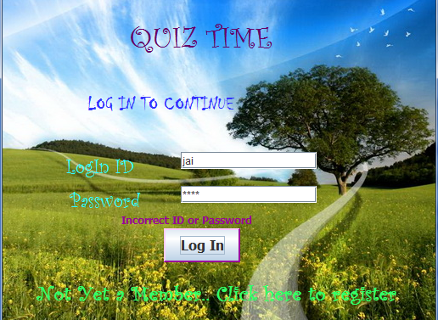 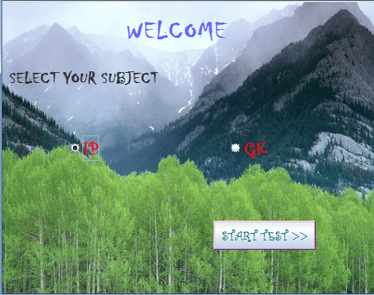 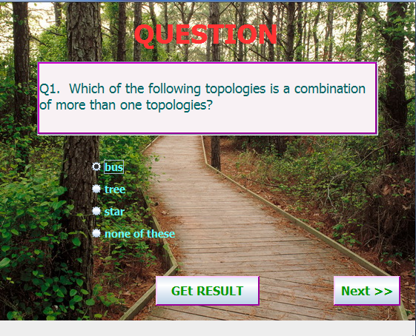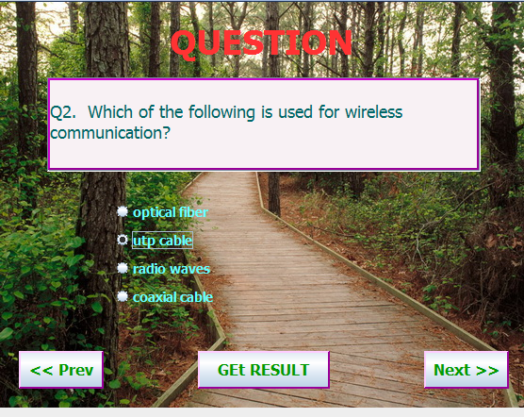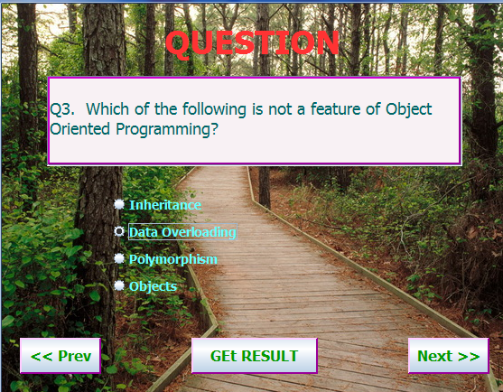

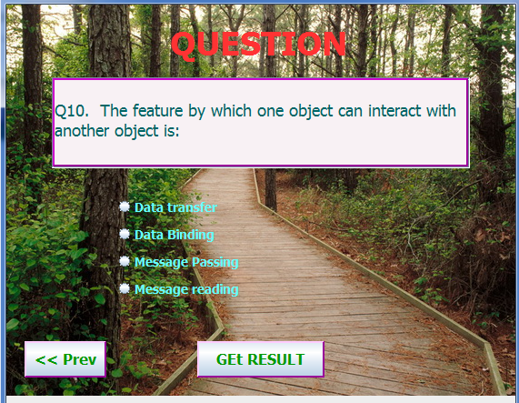 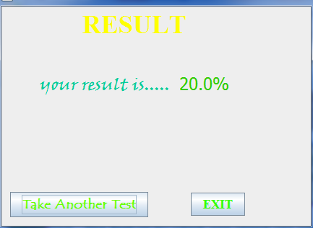

11 | P a g e
sweaters (referred to as "torch sweaters") and children's cowboy chaps which could
easily catch fire and flas...